1. write a procedure to insert record into employee table.

the procedure should accept empno, ename, sal, job, hiredate as input parameter

write insert statement inside procedure insert_rec to add one record into table

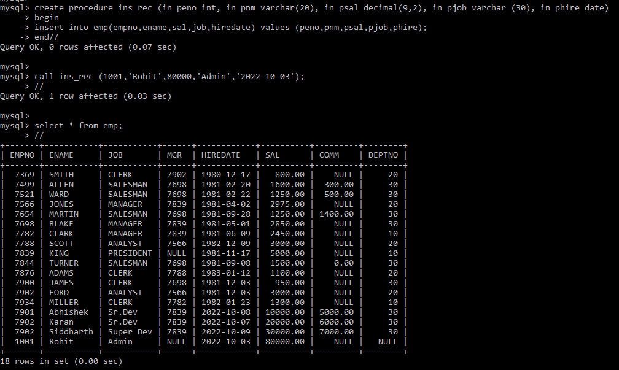

**2. write a procedure to delete record from employee table.**

**the procedure should accept empno as input parameter.**

**write delete statement inside procedure delete_emp to delete one record from emp table**

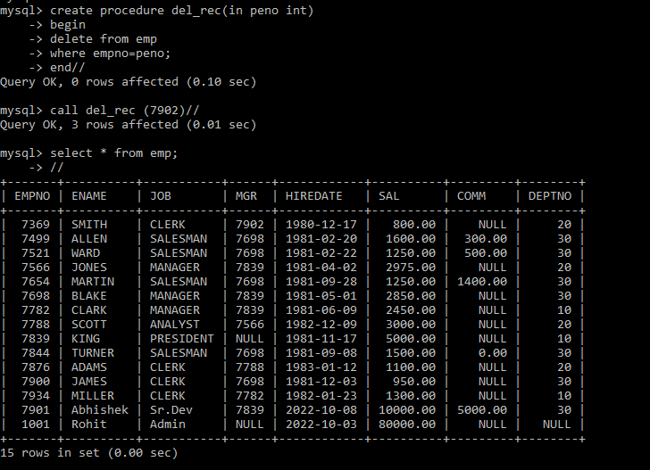

**3. write a procedure to display empno,ename,deptno,dname for all employees with sal > given salary. pass salary as a parameter to procedure**

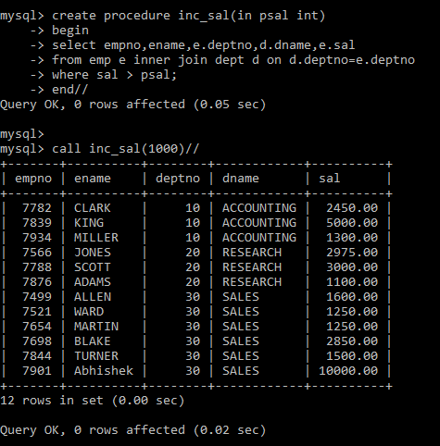

4. write a procedure to find min,max,avg of salary and number of employees in the given deptno.

deptno --→ in parameter

min,max,avg and count ---→ out type parameter

execute procedure and then display values min,max,avg and count

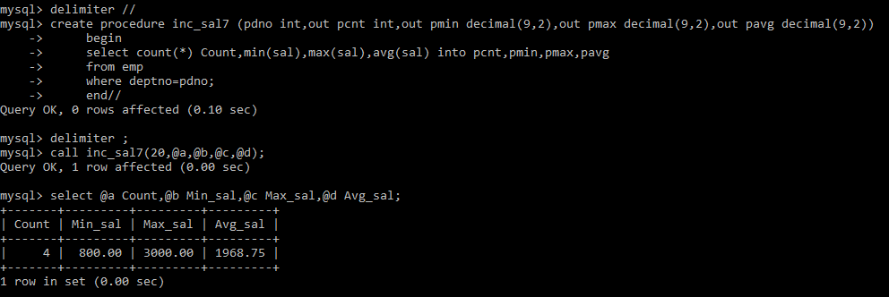

5. write a procedure to display all pid,pname,cid,cname and salesman name(use product,category and salesman table)

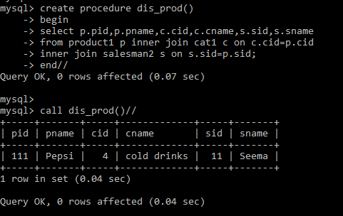

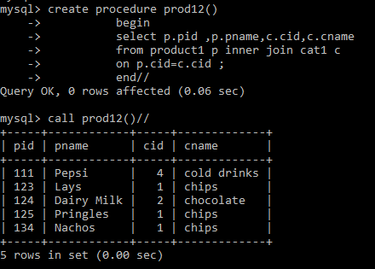

6. write a procedure to display all vehicles bought by a customer. pass cutome name as a parameter.(use vehicle,salesman,custome and relation table)

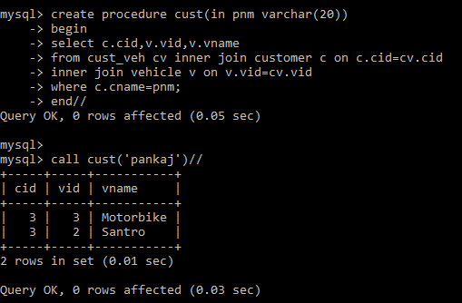

7. Write a procedure that displays the following information of all emp

Empno,Name,job,Salary,Status,deptno

Note: - Status will be (Greater, Lesser or Equal) respective to average salary of their own department. Display an error message Emp table is empty if there is no matching

record.

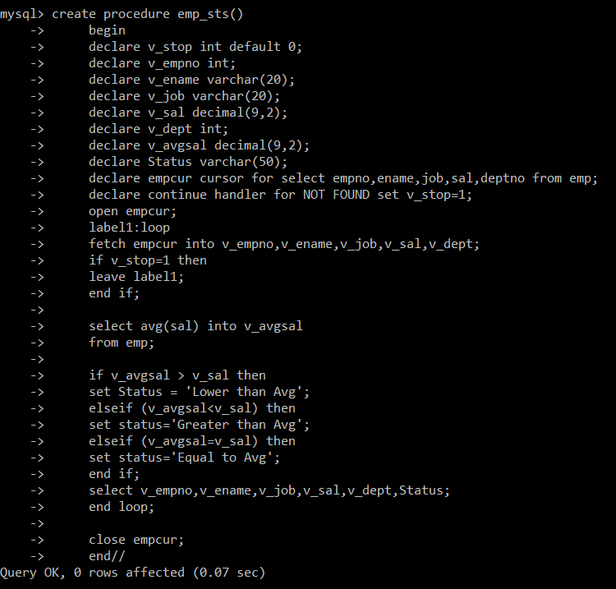

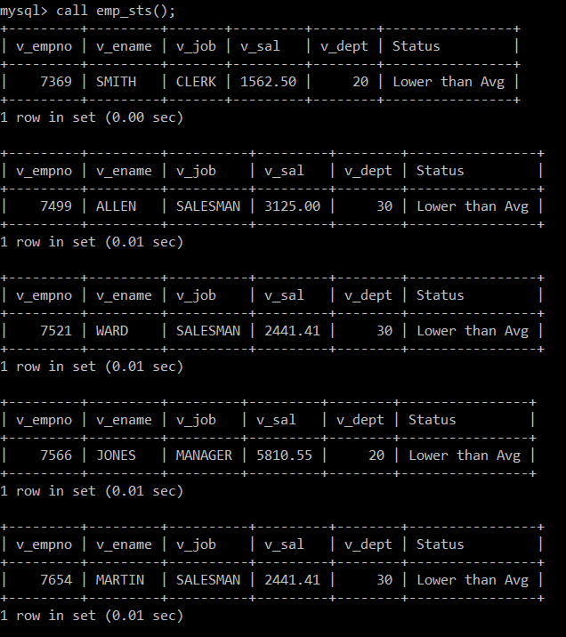

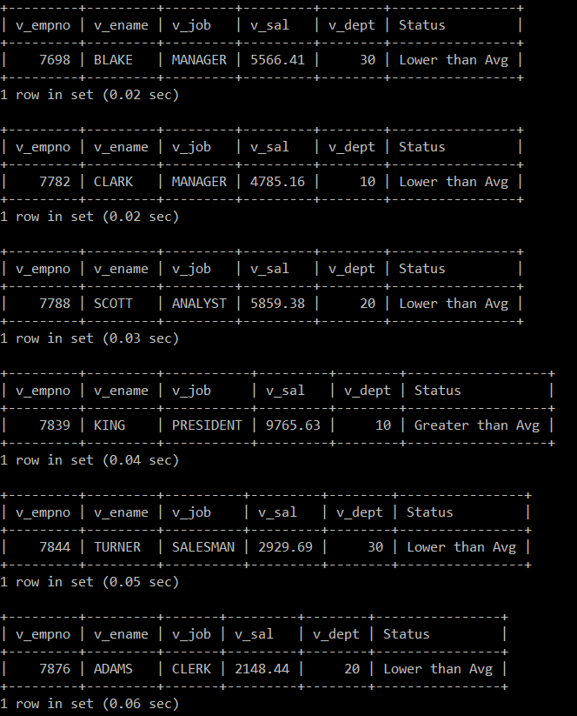

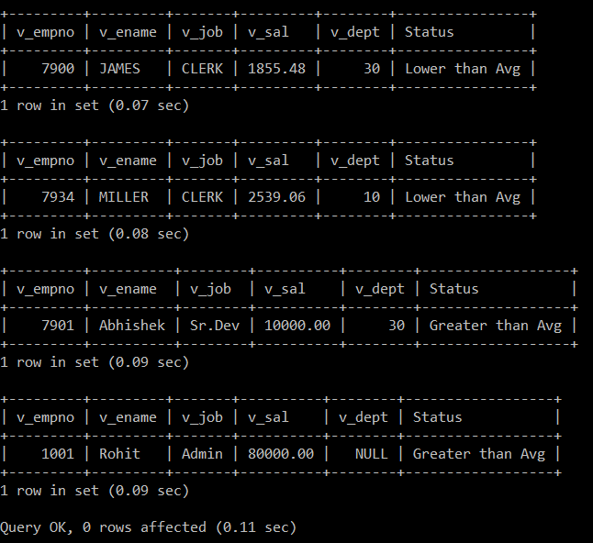

8. Write a procedure to update salary in emp table based on following rules.

Exp< =35 then no Update

Exp> 35 and <=38 then 20% of salary

Exp> 38 then 25% of salary

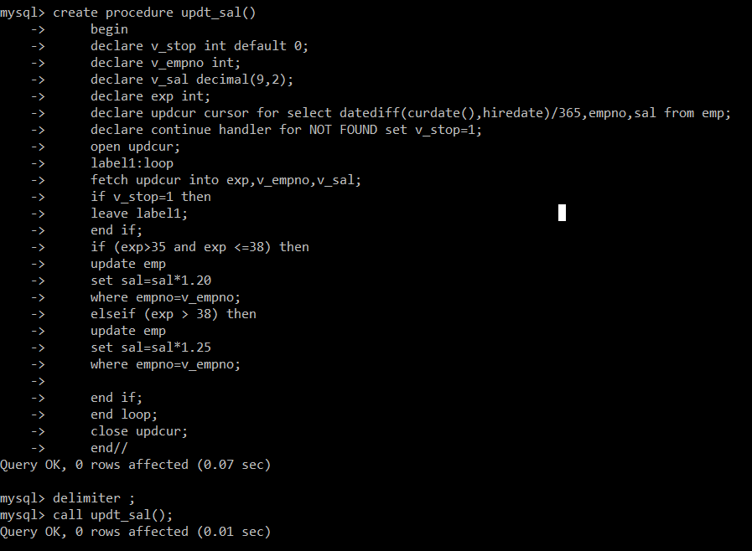

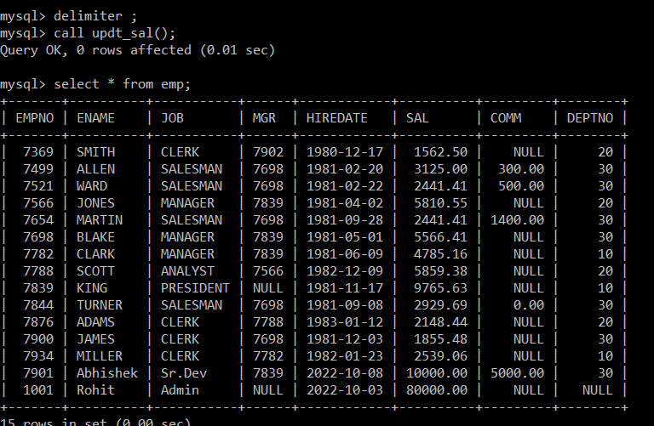

9. Write a procedure and a function.

Function: write a function to calculate number of years of experience of employee.(note: pass hiredate as a parameter)

